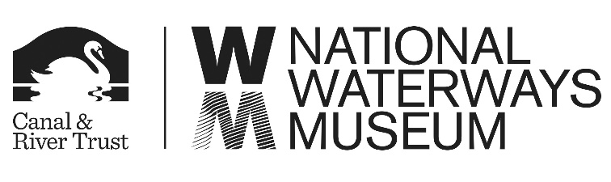

Boat Mooring Application Form
If you would like to apply to extend your moorings in the Upper Basin at the National Waterways Museum please fill out the form below.
Name: | Name of Boat:
Address: | Telephone:
 | Email:
Proposed dates of mooring:

Outline of the history of the boat (please note this information will be used by the museum for interpretation purposes)

What interpretation would you provide about the boat?

Would visitors be able to access the boat? If so, when and what can they see?

Would you be happy for the information about your boat to be shared via Social Media and used in other publicity? (please delete as appropriate) YES NO

Please return this form to:
Michelle Kozomara
National Waterways Museum
South Pier Road
Ellesmere Port
Cheshire
CH65 4FW

Or by email at Michelle.Kozomara@canalrivertrust.org.uk

