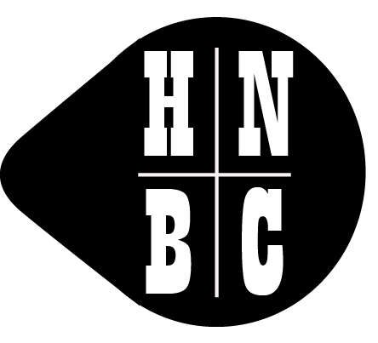
London Gathering: 27 – 29 May 2022
Note: this is NOT the Platinum Jubilee Bank Holiday Weekend
Booking Form
Member Name(s)
Address*
Post Code*
Phone Number(s)*
Email Address*
Boat Name |  |  |  | CRT Index No.
Boat Length including fenders |  |  |  | Number of crew
Arriving From (Tick) | Limehouse Basin |  | Lee Navigation |  |  | Thames via Bow Locks
Special Access requirements, including details of pets on board.
I am willing to help run the event on site (Tick)
I am a trained first aider with current qualification and am willing to be on a rota of first aiders over the weekend (Tick)
* Please tick here to confirm that we may use these contact details to send you further information about the Gathering. Your data will be held in line with the club's policy on General Data Protection Regulations.
We don’t recommend leaving boats unattended for long periods anywhere in the London (or any other urban) area. Please tick the box if you’d like details of any more secure moorings en route we are able to organise
Rickmansworth Festival is the weekend before our event, 20-22 May 2022. Watch the HNBC web site, Facebook page and e-newsletter for details of booking, which opens in January 2022.
Bow Back Rivers / Olympic Park Cruise Please tick the box if you’d like to take your boat round these rarely used waters during or immediately after the event
EVENTS / VISITS
We’re in the process of organising (or trying to organise) some daytime events. Full details will follow, but please indicate the number of people in your crew that might wish to book for the event IF WE CAN ORGANISE IT
Friday Evening Social – Music and supper, food around £15 a head
Booking essential. Please indicate number of people interested
Tour of 3 Mills / House (Tide) Mill On Saturday, 28 May, cost £10 per head. Booking essential. Please indicate number of people interested
Historic Vessel Safari – Thames tugs at Trinity Buoy Wharf, Ships at Museum of London Docklands
Please return this form ASAP, but no later than 5 March 2022 (AGM) to:
Mr M J Pinnock, 21 Forty Hill, Enfield, EN2 9HT OR (preferred option), save the completed form and email to hnbcgathering@outlook.com

