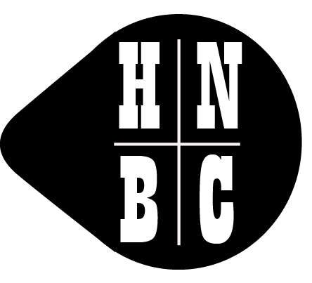 | Auction of Canal Related Antiques and associated items  at  Weston Village Hall, ST18 0JQ  on  Saturday 25 March 2017

REGISTRATION APPLICATION FORM

CLUB MEMBERS
Full name (please print) | HNBC Membership Number
Address | Telephone number(s)
 | Email address
OFFICE USE ONLY
Bidding number

SPONSORED GUEST If you are not a member of HNBC but wish to attend as a guest, please ask your sponsoring Club member to complete their details below and sign the declaration at the foot of this page.

Guest’s full name (please print) | Telephone number(s)
Address | Name of sponsoring Club member (print)
 | Telephone number or email address
OFFICE USE ONLY
Bidding number

Declaration

I confirm I will sponsor the above-named guest to attend the HNBC Auction at Weston Village Hall on 25 March 2017.

Signature of Club member ……………………………………………………………………………

Name of Club member (print) ……………………………………………………………………….

Membership No ……………………… Date ……………………….

